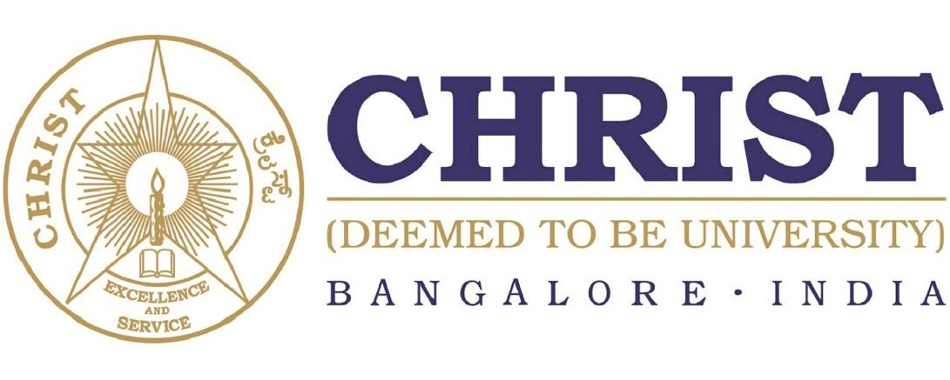

**DEPARTMENT OF**

**COMPUTER SCIENCE AND ENGINEERING**

**CS331P**

**Database Management Systems**

***B. Tech – Computer Science and Engineering***

***(Artificial Intelligence and Machine Learning)***

**School of Engineering and Technology,**

**CHRIST (Deemed to be University),**

**Kumbalagodu, Bengaluru-560 074**

November 2022



***Certificate***

*This is to certify that Ashvath S.P has successfully completed the ~~record /~~ Mini Project work for CS331P - Database Management Systems in partial fulfillment for the award of Bachelor of Technology in Computer Science and Engineering (Artificial Intelligence & Machine Learning) during the year 2022-2023.*

**HEAD OF THE DEPARTMENT FACULTY- IN CHARGE**

**EXAMINER 1:**

**EXAMINER 2:**

Name : Ashvath Suresh Babu Piriya

Register No. : 2162014

Examination Center : SoET, CHRIST (Deemed to be University)

Date of Examination :